

Assignment - 2

Student Name/ID Number: | Viddy Virstandi Paramanayaka Andanawari Purnama
Unit Number and Title: | Database Design & Implementation
Academic Year: | 2022
Unit Assessor: | Arvinder Kaur
Project Title: | Implementing a Database for Community Portal
Issue Date: | 27 July 2022
Submission Date: | 30 July 2022
Internal Verifier Name:
Date: | 30 July 2022

Date: 30 July 2022
Student signature:
I certify that the work submitted for this assignment is my own and research sources are fully acknowledged.
Learner declaration

Purpose of this project
Purpose of this project
To demonstrate your capabilities in the following areas:
- Ability to Implement a MySQL Database based on design created in Mini Project 1
Submission Format
- Screen capture of Database Table structure in PhpMyAdmin
- Queries used by Web pages in Tabular Format
Project Brief & Guidance
Scenario:

Refer to the Project Scenario for the Module Project
You have been approached by ‘ABC Jobs Pte Ltd’ as a website developer to develop a community portal for Software Developers. The project will be carried over through Module 3, Module 4, Module 5 and Capstone project. For this module the scope is to Design, Develop, Implement & Document Struts Framework Website.
The Scope of the Project is to design a Community Portal Similar to Linkedin.com. Users will be able to register in the portal using the Registration Page. Users of the portal can search for other users using various parameters such as First Name, Last Name, Company Name, City & Country. Users will be able to view the Public Profile of users after searching them. The portal allow users to login, request for forgotten password and Update their profile information
The scope of the mini project is to implement the database in MySQL.
The overview of the project is as below
There are 2 types of users in this Community portal. They are
- Software Programmer
- Administrator

Software Programmer should be able to perform following functions in the portal
- Allow the programmers to register in the portal, show a thank you page & send a registration confirmation email.
- Search & Find Other Programmers after login and view their profile.
- Provide Login Page
- Provide password retrieval functionality.

- Update their Profile after logging in.

Following Functionality is part of Database Design & Will be enhanced as features as required in the Capstone Project, Depending on time availability.

- Send Messages to Each Other on the Portal
- Create Threads & Post Replies to a Thread
- Post Job Opportunities in the Portal

Administrator should be able to perform following functions in the portal
- Administer user data.
- Send bulk email inviting programmers to register on the community portal

The portal consist of the following Key pages (For Reference)
- Community Portal Home Page
- Registration Page
- Registration Confirmation Page
- Update Profile Page
- Search Users Page
- List Search Results
- Public Profile Page
- Registration Confirmation Email
- Login Page
- Forget Password Page
- Design the Forget Password Confirmation Page

Following Functionality is part of Database Design and will not be part of development & Will be enhanced as features are required in the Capstone Project, Depending on time availability.
- Send Messages
- Read Messages
- Post in Message Board
- List Message Board
- Read A Thread
- Post Job Opportunities
- List Job Opportunities & Responses

The scope of this assignment
The scope is to Implement the database in MySQL
  - Create the tables based on design in Mini Project 1
  - Take note of Field Name, Field Type & Size
  - Implement the database in MySQL and provide screen capture
  - Create a user name in MySQL which can be used by the application, give required access privileges. (Provide screen capture of the user with access privileges)
e. Briefly list the web pages in the Community portal and queries which will be used by each of them.

- Create the tables based on design in Mini Project 1
Entity Name | Table Name
User | - user_id  - first_name  - last_name  - company  - city  - country  - email  - password
User Profile | - user_id  - status_id  - username  - job_status  - experience  - company  - bio
Admin / Administrator | - admin_id  - first_name  - last_name  - email  - password
Jobs | - job_id  - company_name  - job_desc  - job_type
Thread | - thread_id  - date  - time  - thread_desc  - comment
Message | - message_id  - date  - time  - message  - to  - from

- Take note of Field Name, Field Type & Size

Entity Name | Table Name
User | TB_User  Field Name Field Type Size  user_id (PK) int 11  First_name varchar 48  Last_name varchar 48  company varchar 48  city varchar 48  country varchar 48  email varchar 64  password varchar 32
User Profile | TB_User_Profile  Field Name Field Type Size  user_id(PK) int 11  Status_id int 11  username varchar 16  Job_status varchar 24  experience varchar 24  company varchar 48  bio varchar 500
Admin / Administrator | TB_Admin  Field Name Field Type Size  admin_id (PK) int 11  First_name varchar 48  Last_name varchar 48  email varchar 64  password varchar 32
Jobs | TB_Jobs  Field Name Field Type Size  jobs_id (PK) int 11  company_name varchar 24  Job_desc varchar 500  Job_type varchar 10

Thread | TB_Thread  Field Name Field Type Size  thread_id (PK) int 11  Date date  Time numeric 8  Thread_desc varchar 500  comment varchar 255
Message | TB_Message  Field Name Field Type Size  msg_id (PK) int 11  date date  time varchar 8  message varchar 255  to varchar 48  from varchar 48

- Implement the database in MySQL and provide screen capture
Creating DATABASE
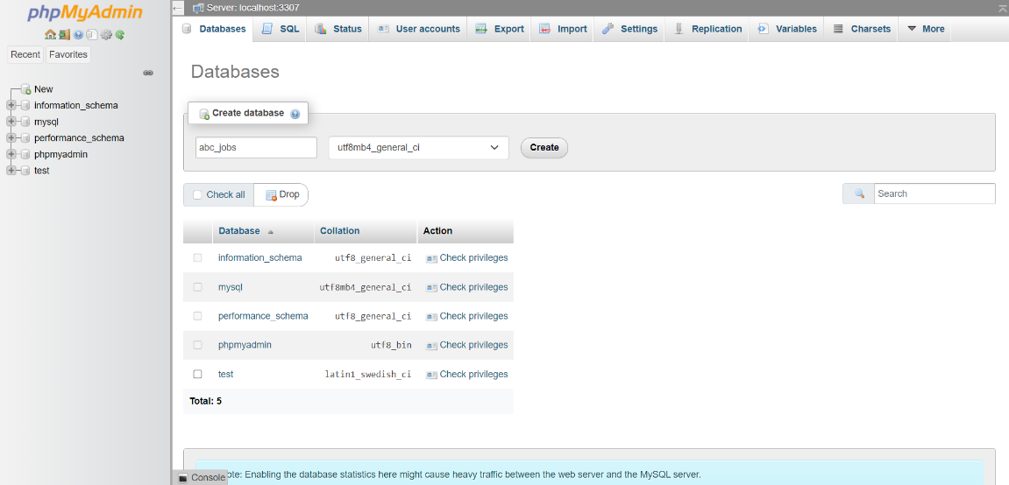

Creating Table
- Creating User Table

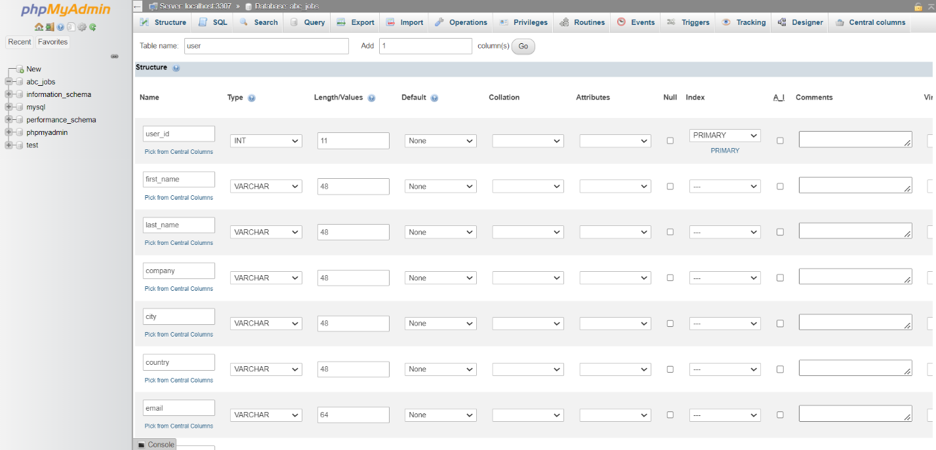
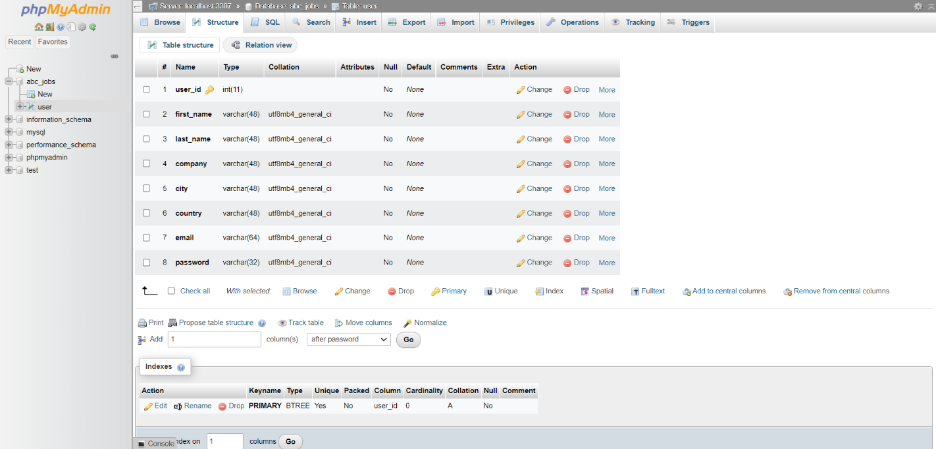

- Creating User Profile Table
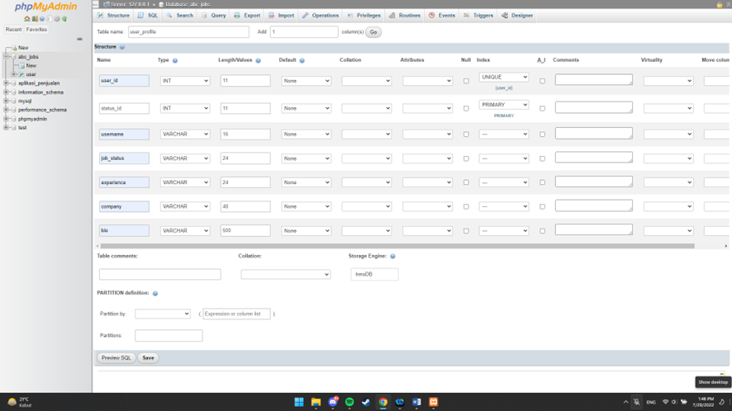
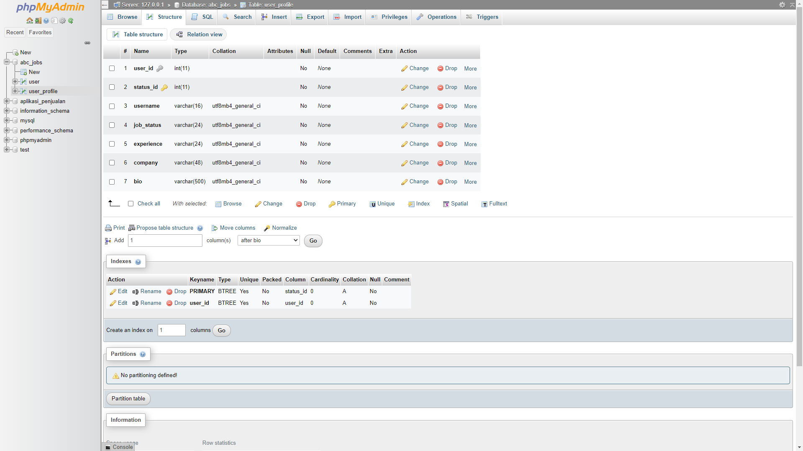

- Creating Admin Table
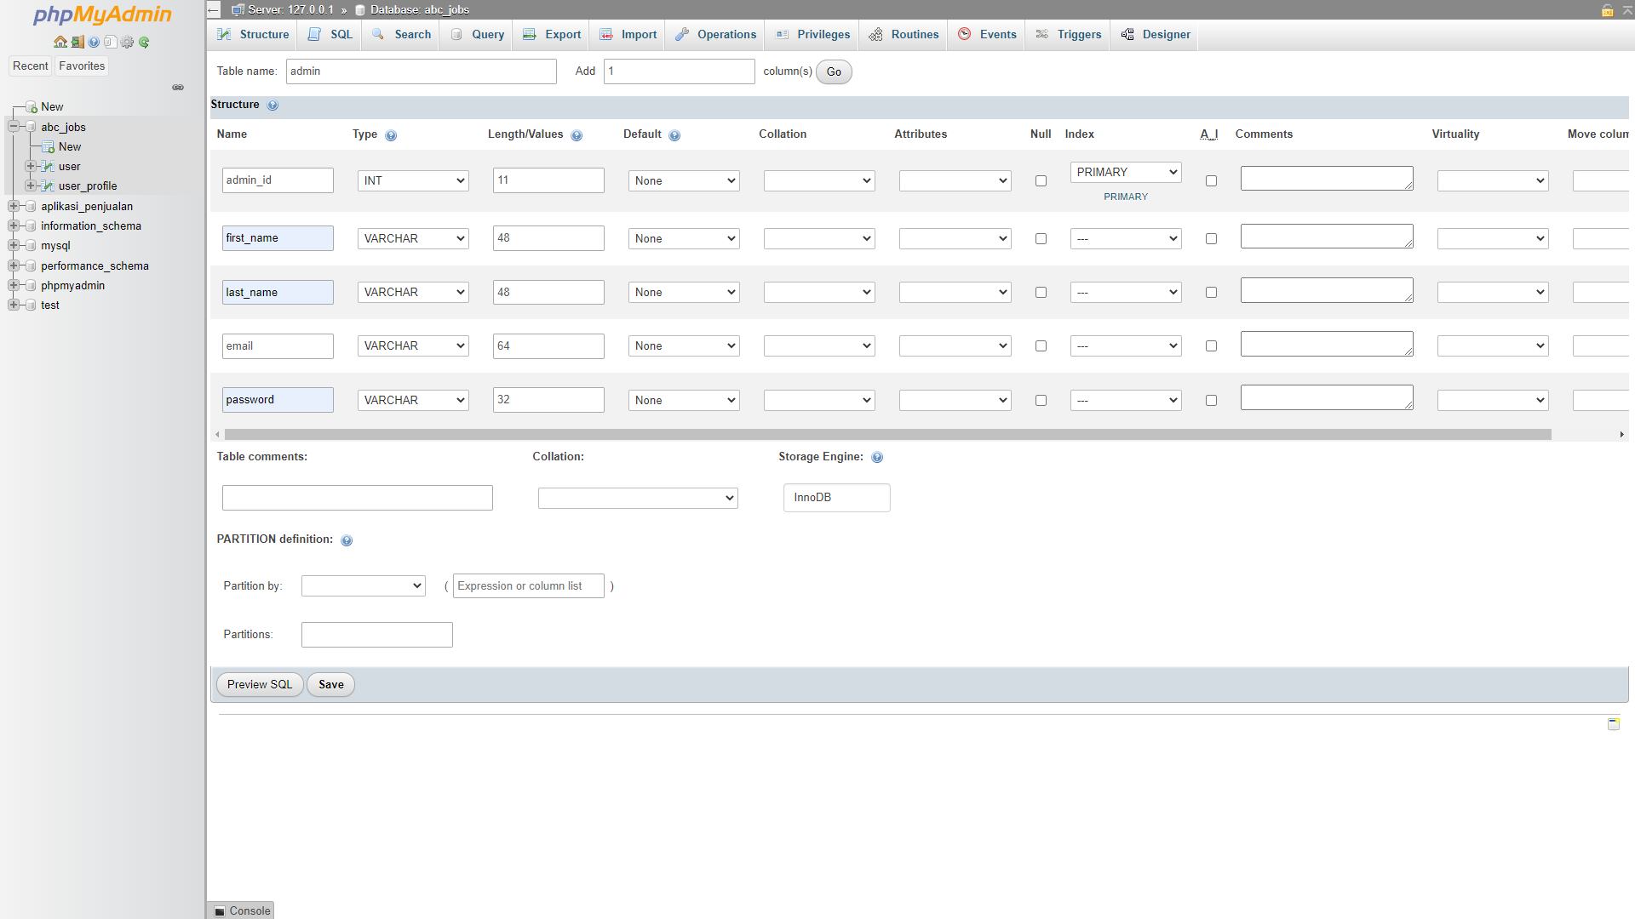
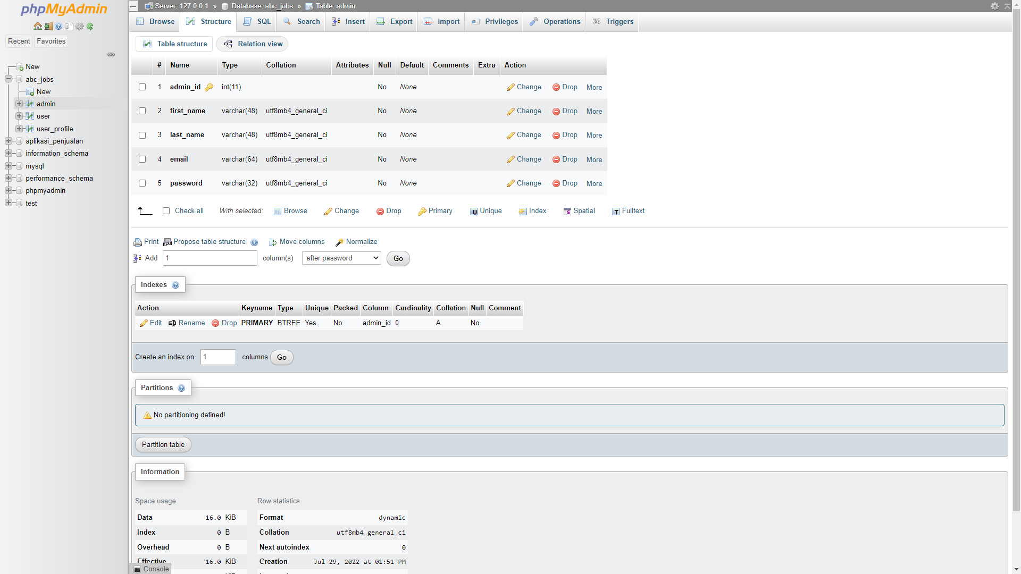

- Creating Job Table
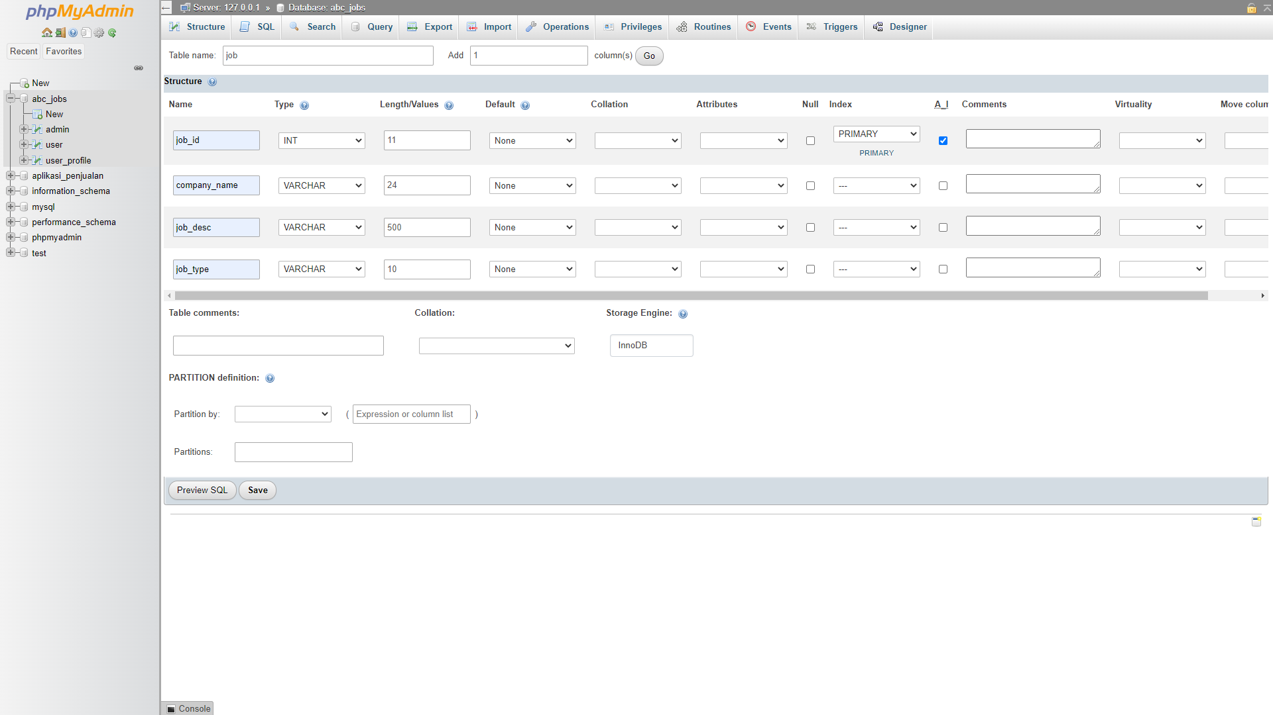
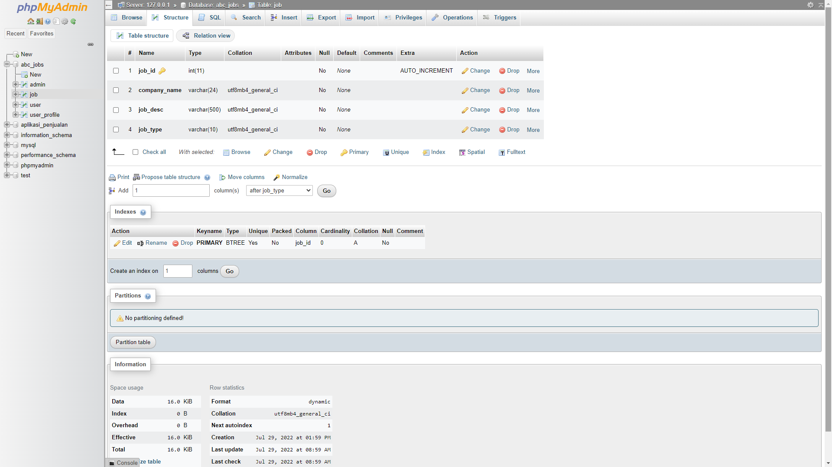

- Creating Thread Table
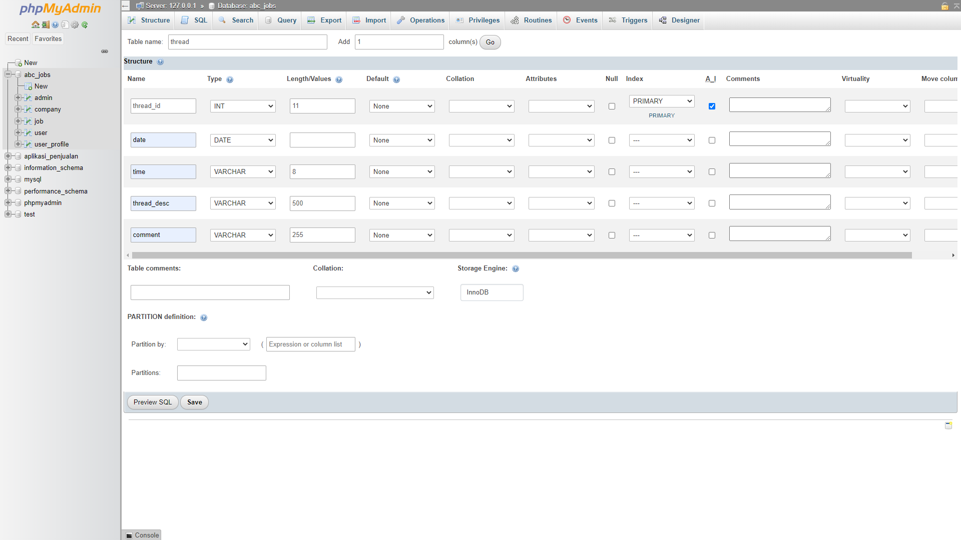
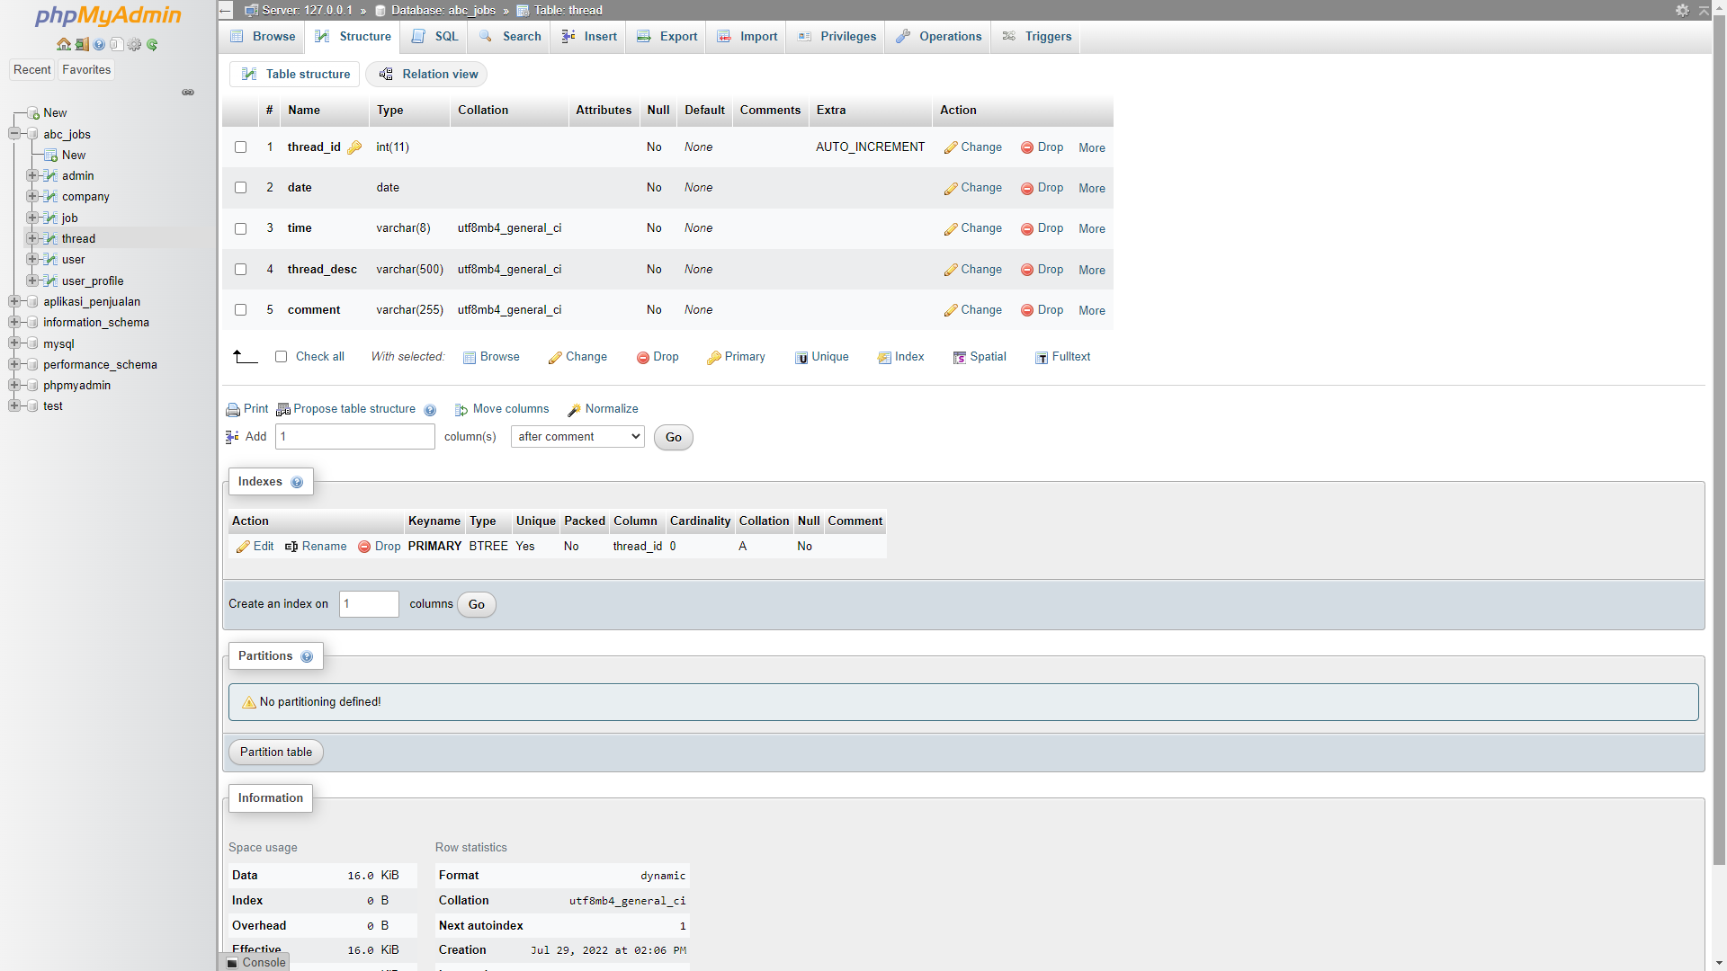

- Creating Message Table
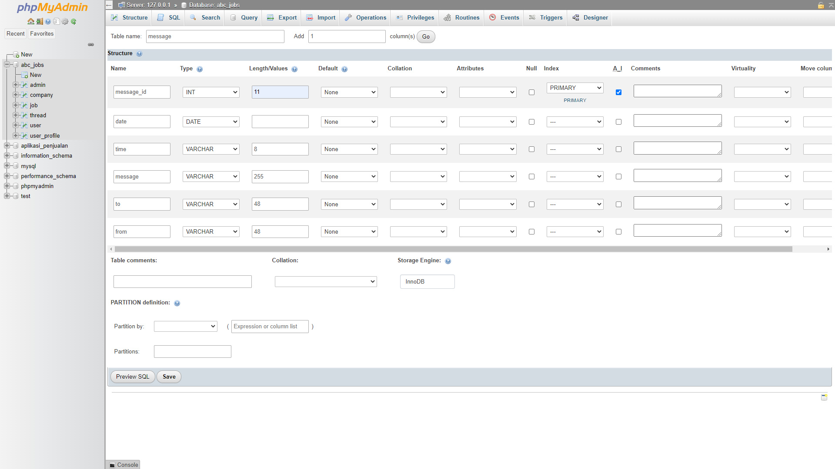
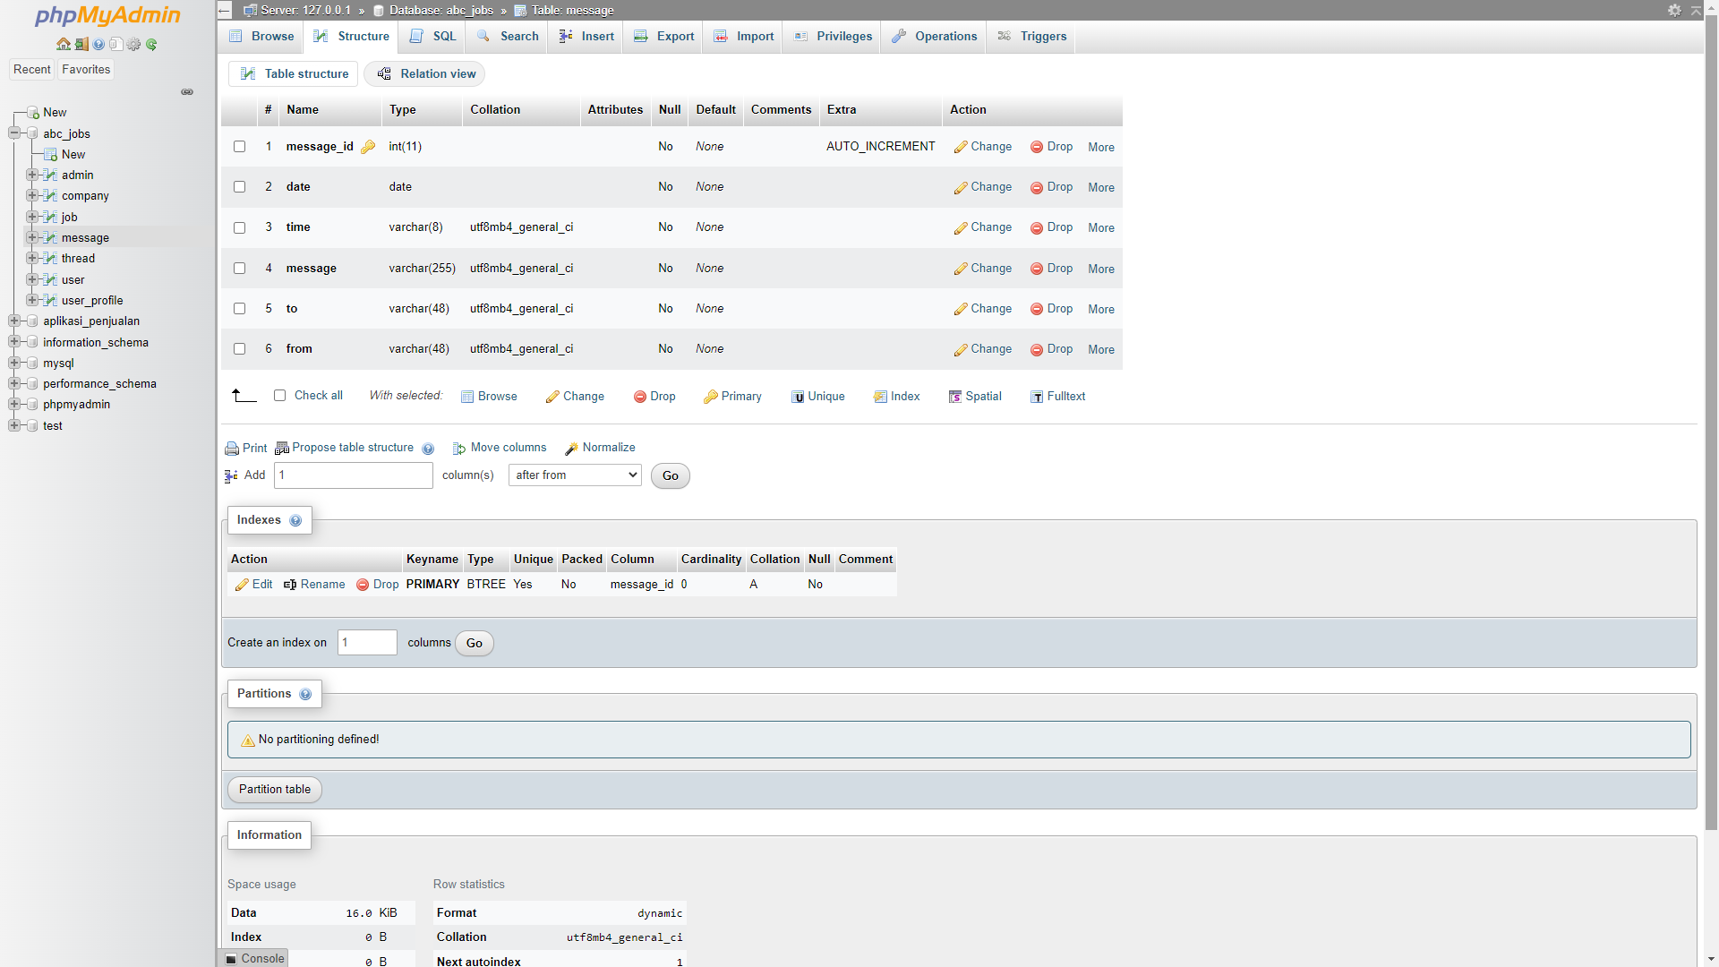

- Create a user name in MySQL which can be used by the application, give required access privileges. (Provide screen capture of the user with access privileges)

- CREATE USER 'root2'@'localhost' IDENTIFIED BY '123456';
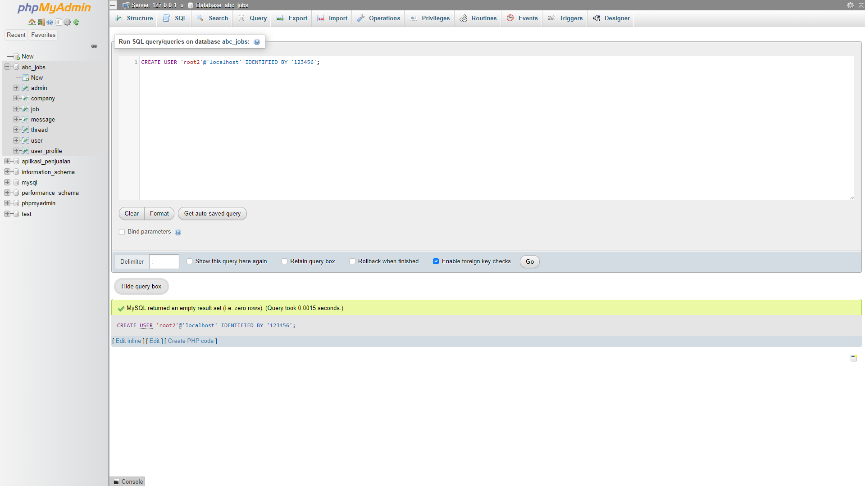

- GRANT ALL PRIVILEGES ON bdse04 . * TO 'root2'@'localhost';
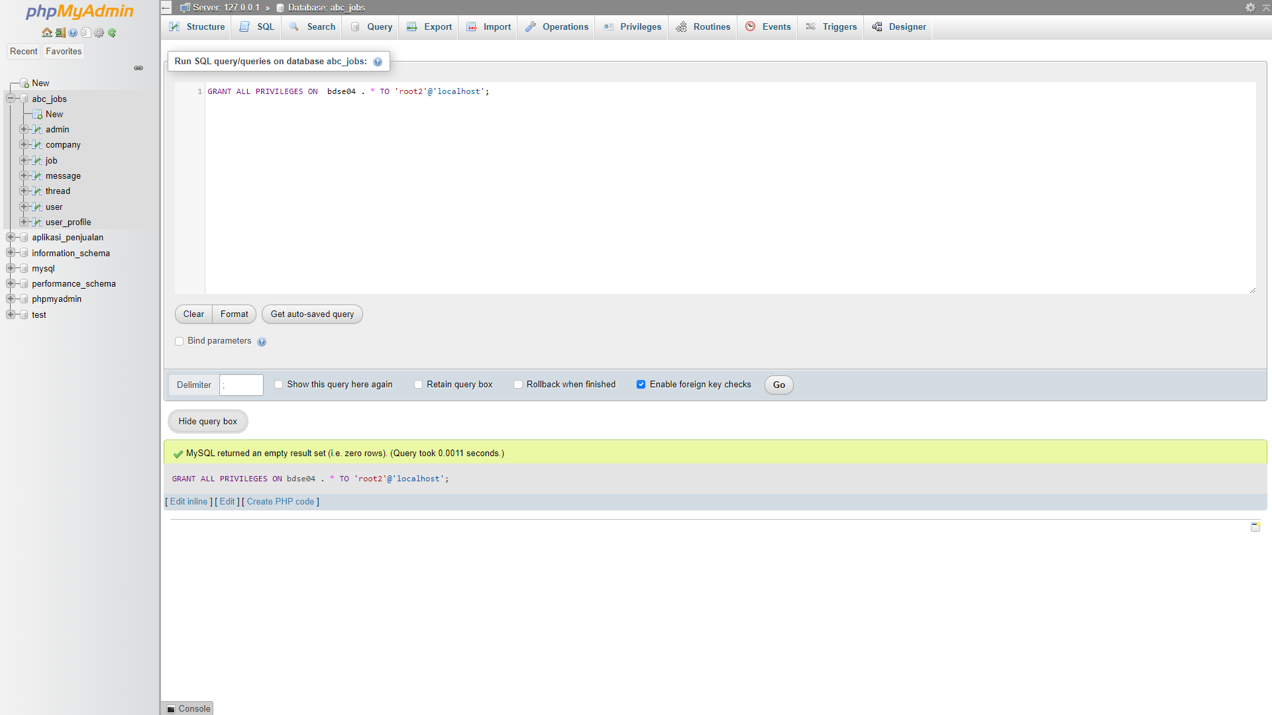

FLUSH PRIVILEGES;

REVOKE ALL PRIVILEGES ON * . * FROM 'root2'@'localhost';

DROP USER 'root2'@'localhost';

- Briefly list the web pages in the Community portal and queries which will be used by each of them.

sno | Page Name | Query
1 | Registration Page | INSERT INTO user  VALUES (1, 'Viddy', 'Purnama, 'Google', 'Reykjavik', 'Iceland', 'Ncull@email.com', 'password12345');
2 | Login Page | SELECT * FROM user  WHERE email='Ncull@email.com' and password='password12345';
3 | Search Page | SELECT * FROM user  WHERE first_name LIKE 'searchField' OR last_name LIKE ‘searchField’ OR company LIKE ‘searchField’ OR city LIKE ‘searchField’ OR country LIKE ‘searchField’;
4 | Profile Edit Page | UPDATE user  SET company = ‘Intel’, city = ‘Bandung’  WHERE user_id = 1;
5 | Post Thread Page | INSERT INTO thread  VALUES (1, ‘10/2/2021, ‘10:35 PM’, ‘I’m Very Happy’, ‘Happy’);
6 | Send Message Page | INSERT INTO message  VALUES (1, ‘29 July 2022’, ‘09:55 AM’, ‘Hello there’, ‘Amir El-Amari, ‘Viddy Purnama);
7 | Read Message Page | SELECT * FROM message;
8 | Forgot Password Page | SELECT * FROM user  WHERE email=’Ncull@email.com’;
9 | Read Thread Page | SELECT * FROM thread;
10 | Post Job | INSERT INTO job  VALUES (1, ‘Google’, ‘We are looking for Full Stack Developer’, ‘Full-Time’);

